NEW

**SOLUTIONS**

**Verbal Ability**

1.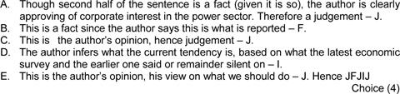

2.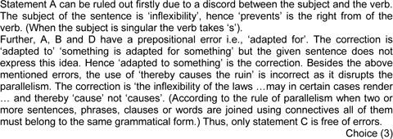

3.

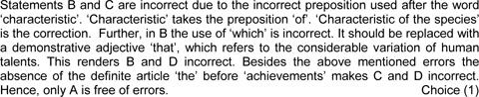

4.

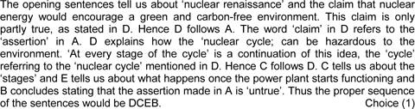

5.

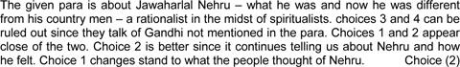

6.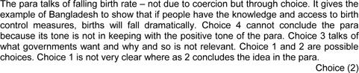

7.

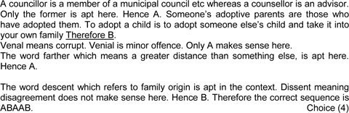

8.

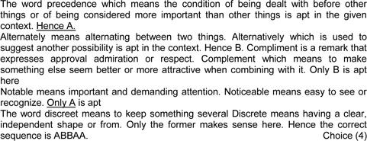

9.



10. 

11.

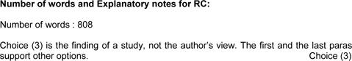

12.

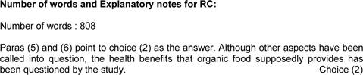

13.

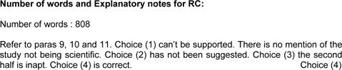

14.

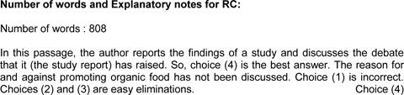

15.

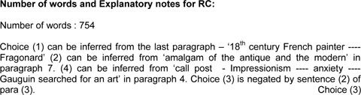

16.

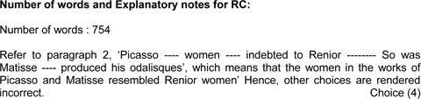

17.

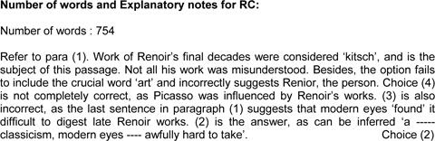

18.

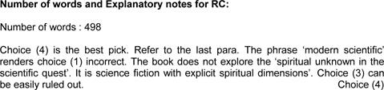

19.

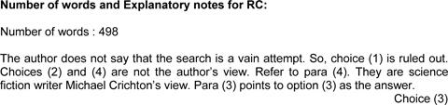

20.

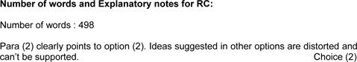

21.

Answer (E)

The passage does not talk about "absence of strong biological linkages". Hence, option A is wrong.

The statement in option B does not agree with the passage. Hence, option B is wrong.

Option C is contrary to the passage.

The passage never stated that human behaviour depends on biological linkages. Hence, option D is wrong.

Option E correctly captures the theme of the passage.

22.Answer (B)

We must look for an option that we do not consider as normal.

Except option B, all the options are normal.

For example, it is absolutely fine with us if a waiter serves more than that is expected from him.

But we are offended when a father behaves in a tongue in cheek manner. If biological linkages structured human society, it should not matter to us how a father behaves. Hence, option B is the correct answer.

23.Answer (D)

Statement A has been discussed in the passage while giving the example of clergymen and waiter. Hence, it is correct. By the example of the father, we can say that statement B is true.

In the passage, the author has not mentioned that development of skill may result in denial of the self. So, statement C is incorrect.

So, only statements A and B are correct. Option d) is the correct answer.

24.Answer (A)

There is no need of the word ‘to’ between returned and home in sentence A

In statement B, the correct use of the phrase is hands on and not ‘hand on’

In statement D, there should be a hyphen or comma after the word Shailach(a shailach-a sort of recruiter to

Minneapolis).

25. The usage of the word "so" is inappropriate => A is wrong

"Assuming hypothetically" is redundant => Only one of the words can be used here.=> C is wrong.

"a temporary stimulus" is the correct phrase => D is wrong.

"long term" is the correct phrase and not "longer term" => E is wrong.

Hence, only B is correct

26. In sentence A, the word "said" must be used instead of "told". Sentence B is correct.

In sentence C, 'handed to us' should be replaced with 'handed down to us'. Sentence D is correct.

In sentence E, 'hence' should be replaced with 'but' or some other conjunction that is similar in meaning to 'but'.

So, only B and D are correct.

27. The sentence "the arts wield their creative power not so much ............ a new horizon from a new horizon" says that the art words do not differ in their "width" and "breadth" as well as "life" and "interpretation of life". => Options C and D are wrong.

Option A is irrelevant as it is not discussed in the passage.

The comparison between Madonna and modern day singer is not correct => option E wrong.

Option B is the answer.

28. After giving the example of "sea" and "the other creation", Rilke says "I suddenly understood the situation of the poet, his place and his function in this age".

Option a) captures this idea succinctly. None of the other options are applicable.

Option A is the correct answer.

29. Refer to the following lines of the paragraph: "Adventurers of experience set out as though in lifeboats to rescue and bring back to the shore treasures of knowing and feeling which the old order had left floating on the high seas. The works of the early Renaissance and the poetry of Shakespeare vibrate with the compassion for live experience in danger of dying from exposure and neglect."

Here the author refers to the poets of renaissance as adventurers of experience.

Option c) is the correct answer.

30. The paragraph describes the role of the characters in the whole story. Then the paragraph moves to the macro-level stories where the organisation does not tell the whole narrative .Option 5 extends the idea about the purpose of personification of whole organisation. Option 1 and 4 are incorrect because of the deviation from the topic. Option 2is incorrect as it talks abstracting away from the actors rather than explaining the reasonbehind it. Option 3 is incorrect as there is nopoint of invoking the importance of personification of organisation.

31. The paragraph starts by talking about the retaining of the allure of the photographs. It describes the new digital age where the photos have become digital. Option A perfectly ends the paragraph by talking about the positives of the photographs.  
2,3,4 are deviations from the main idea. 5th is close but it introduces a new idea rather than closing the paragraph.

32. No inventory would ever include those, of course’. The para starts with listing out ‘the inventory’. The option which says ‘what she lacked natural shrewdness’ is beyond the scope of the argument. All the options can be easily eliminated. ‘Those’ in the option ‘No inventory would ever include those, of course’, refers to human intuition and intelligence of Mama Ramotswe.

33. The main point of the first paragraph is to define what are accepted rules and how to identify them. In the second paragraph, the author talks about comparing different sets of accepted rules or community paradigms and analysing them. In the last paragraph, the author talks about how paradigm, even if they cannot be distilled into rules, can yet guide research and be widely accepted. Thus, the main point of the passage is how to understand scientific paradigms.

Option a) is an answer to how the author is attempting to illustrate his point through the passage. It does not answer the 'what' part.

Options b), c) and e) give only partial answers to what the author is trying to illustrate through the passage.

Hence, Option d) is the correct answer.

34. In the first line of the passage, the author describes loci of commitment as accepted rules. The passage talks about the historian trying to isolate the particular loci of commitment, which he later concludes as the community's paradigms.

Option c) succinctly captures this idea. None of the other options are applicable.

35. Throughout the passage, the author highlights that "the paradigms" are "the general rules of science".

Rules are difficult to be defined. On the other hand, paradigms can follow without any rules. Option e) accurately represents the idea.

36.Cricket Council is a collective noun so it takes a singular verb. The reference is made to a group as a whole and not to an individual.  
So correct option for 1st sentence is AA.  
Censure implies harsh criticism. Censor means to put a ban on something objectionable. So Censure should be the correct answer here.  
Credible means capable of being believed. Credulous means tending to believe without evidence. So credible should be used for 3rd sentence.  
Discretely means distinct whereas discreetly means to carefully avoid social embarrassment or distress; tactful. So use of ' discreetly' is correct here.  
Hence option D.

37. Use “farther” for physical distance and “further” for metaphorical, or figurative, distance. So further should be used here.  
Correct usage for 2nd sentence is 'historic event', which means 'an event of great importance'.  
In sentence 3, the word 'distrust', which means 'the feeling that someone or something cannot be relied upon' should be used.

The correct usage is sentence 4 is 'true' story.  
A backhanded compliment, also known as a left-handed compliment or asterism , is an insult that is disguised as a compliment.

Option e) is the correct answer.

38. 'Decline regretfully' is the correct usage. It means being sorry to decline.  
Sensuous means taking delight in beauty. Hence is perfect for 2nd sentence.   
Beside means next to. Besides means apart from or and another thing. So 'beside' should be used in given context.  
Stationary means 'stand still'. Hence is the correct for usage in 4th sentence.   
5th statement can be correctly written as, ' As the water began to rise above the danger mark, the signs of an imminent flood were clear.'

Option e) is the correct answer.

39.Consider the following lines from the passage: "Those include confounding effects of natural variation in additional variables besides the one of interest, as well as problems in inferring chains of causation from observed correlations between variables."  
This explains the reason why islands with considerable degree of isolation provide valuable insights into human history. Option c) is the correct answer.

40. Refer to the following lines "Prediction in history, as in other historical sciences, is most feasible on large spatial scales and over long times, when the unique features of millions of small-scale brief events become averaged out. Just as I could predict the sex ratio of the next 1,000 new born but not the sexes of my own two children. the historian can recognize factors that made inevitable the broad outcome of the collision between American and Eurasian societies after 13,000 years of separate developments, but not the outcome of the 1960 U.S. presidential election"

From this we can understand the reason why the author says prediction in history is difficult is because historical sciences suffer from the inability to conduct controlled experiments. Option e) is the correct an swear.

41. Refer to the lines "The student of human history can draw on many more natural experiments than just comparisons among the five inhabited continents. Comparisons can also utilize large islands that have developed complex societies in a considerable degree of isolation (such as Japan, Madagascar. Native American Hispaniola, New Guinea, Hawaii, and many others), as well as societies on hundreds of smaller islands and regional societies within each of the continents."

From this, we can understand that the students of history are missing opportunities by not studying a sufficient variety of natural experiments. Option c) is the correct answer.

42. E follows A because it creates an analogy and explains the situation.

Then, C follows E because, it continues that analogy.

Also statements BD is a pair as B talks about some support and contradiction of work and D talks about conclusion of work and difficulty in connections.

Hence ECBD is the answer.

43. Sentence A talks about 2 discernible forces . Sentence E starts with "in addition, a third". Hence, AE is a mandatory pair.

"These frameworks" in sentence D is explained in E. So, it only makes sense for D to follow E.

Through the words "dominant discourse" in sentence B and "historical work" in sentence C, we can say that C follows B.

=> EDBC is the answer.

44. The argument given by VedeHadiz in statement E is not discussed in any other sentence => sentence E is last.

Out of B and C , B is appropriate statement which should follow A because the first sentence talks about formal governance shifts and B correctly follows by talking about the general political system in Indonesia.

After discussing about changes in political system, discussing about changes in mass media would be apt => C follows B

=> B - C - D - E is the answer

45. "Squatters" mentioned in sentence A is discussed in sentence C => C follows A.

After description of who squatters are, description of squatters' land would be apt => B follows C.

The sentence "The maize grew up ...... " in sentence B needs sentence E to follow it to make sense.

=> C - B - E - D is the answer.